**CASE STUDY: FLIGHT DELAYS**

1. **ABSTRACT**

The purpose of this study is to examine whether certain seasons of the year are more suitable for travel, have significantly less flight delays, than others. The data were obtained from the United States Department of Transportation and include flight details between the years 1994 and 2016. The primary hypothesis is that there us a difference between seasons’ delay percentages. A non-parametric Wilcoxon test and Analysis of Variance test are performed in order to observe any differences between the seasons and their flight delay percentages. Both tests conclude that there is at least one distribution of flight delays for some seasonal pair that is different, at least one of the mean total flight delays differ across seasons. T-tests are also show that there insufficient evidence to say that the flight delays for winter and summer are not equal. However, the flight delay percentages for winter and summer are greater than spring’s which is greater than autumn’s, supporting the primary hypothesis.

**II. BACKGROUND**

When considering airfare travel some of the most important aspects are ticket prices, travel hours, and number of layovers. People rarely think about the possibility of delays, cancellations diverted flights. Flight cancellations and delays can have serious negative effects on passengers, especially, if costs are significant. According to Baumeister et al. (2001), events “that are negatively valenced...will have a greater impact on the individual than positively valenced events of the same type” (p. 323). Delays are considered to be a serious and widespread problem in the United States. Increasing flight delays also place a significant burden on the US air travel system and society in general in terms of cost. (Zou & Hansen, 2010, p. 1). For instance, in 2007 the U.S. Congress found that flight delays cost the U.S. economy about $40.1 billion. Delays burned about 740 million gallon of fuel and released about 7.1 million metric about tons of carbon dioxide (Blackwood (2001) p. 8). In 2017 the estimated annual cost of flight delays for passengers was $26.6 billion.

In the United States, airlines are not required to compensate passengers when flights are delayed or cancelled. Airlines are only required to required, by U.S. law, to compensate certain passengers when they are bumped from a flight that is at capacity (U.S. Department of Transportation, 2018). Studying delays and cancellation is important because of the emotional and monetary cost involved for passengers, airlines and society. Travellers need to be aware of the frequency of flight delays and cancellation when planning their travel. While airlines should realize that on-time arrival is one of the major factors of the customer experience and satisfied customers will return, provide positive reviews and help increase profits (Dyer, 2016). The purpose of this case study is to determine whether some seasons of the year are more suitable for travel compared to others, using flight data from the United States Department of Transportation between 1994 and 2016.

**Related Work**

In a previous study on flight delays, *Flight delay impact on airfare and flight frequency: A comprehensive assessment*, Zou & Hansen (2010) analyzed the cost components of flight delays. Zou & Hansen (2010) utilized a bottom-up approach, taking the negative impacts of flight delay cost and extrapolating to all parties involved and the United States economy. The cost components analyzed included the cost to airlines, cost to passengers, cost of lost demand, and indirect impact of flight delays on the United States economy. Zou & Hansen (2010) utilizes several dummy variables in the models. The “Vacation [variable] intend[s] to capture the effects on...leisure-travel oriented markets. The Vacation variable is expected to account for the greater fare sensitivity of leisure travelers. One would therefore expect a negative impact on yield...[They] further consider three quarterly dummies (Q2, Q3, Q4) which may capture any systematic seasonal effects on airfare” (Zou & Hansen, 2010, p. 9). With everything else being equal, Zou & Hansen (2010) expected “vacation segments to have fewer flights, because of a higher portion of leisure passengers who place less value on frequent service. This effect will be captured by the Vacation dummy” (p. 20).

In regards to methodology, Zou & Hansen (2010) first found descriptive statistics for all variables in their frequency model including the Vacation variable, then the Two-Stage Least Square method for estimation results with their frequency model. Zou & Hansen (2010) concluded that “because there are more leisure travelers on vacation routes, airfares on such routes are 18.1% lower on non-stop routes, and 10.4% lower on one-stop routes, than on comparable non-vacation route” (p. 16). There also were seasonal trends with fare, when “everything else being equal, airlines on average charge 0.5% and 0.3% more on non-stop and one-stop routes respectively, in the second quarter than in the first quarter. By contrast, airfare would be 3 to 6% lower in the two remaining quarters” (Zou & Hansen, 2010, p. 16).

Though the variables in the United States Department of Transportation’s 2016 dataset, given Zou & Hansen’s (2010) findings, there are certain trends that ought to be assessed, for example, seasonal changes in the total number of flights and the subsequent number of delays. With the 2016 United States Department of Transportation dataset, given the trends Zou & Hansen (2010) found, trends between months, in particular vacation months, and the number of arrival delays and total number of flight operations ought to be analyzed.

Blackwood (2012) also analyzed flight delays and the influence of certain months. Just as Zou & Hansens (2010) included a Vacation variable to account for changes in leisure-related seasonal travel, so too did Blackwood (2012) examine the effect of seasonal travel on flight delays. The dataset Blackwood (2012) analyzed included one delay category with respect to Chicago’s O’Hare International Airport, similar to the currently studied dataset from the U.S. Department of Transportation (2016) which includes total delays throughout the United States as one variable. Blackwood (2012) used SPSS to perform an Analysis of Variance test “to determine the individual impact among the various causal factors of delays” (Blackwood, 2012, p. 47). At the end of a season of travel, Blackwood (2012) anticipates that airlines will “make better demand forecast, and ultimately, better connection schedules” (p. 56) which will inherently reduce the risk of yet a second increase in delays in the season. Blackwood (2012) found that “weather…[was] very much inconsequential to [an airport’s]... overall on-time performance. In 2010 weather accounted for only 6 percent of...departure delays” (Blackwood, 2012, p. 103). Seasonally, Blackwood (2012) concluded that “the months of June and September are prime candidates of lengthy...delays” (p. 104).

Just as Blackwood (2012) focused on seasonal and monthly changes, testing to see if weather significantly affects delays, Sridhar et al. (2009) also describes models for predicting weather-related flight delays. Sridhar et al. (2009) utilizes traditional linear regression to create delay estimation models. They found that weather is a “good proxy for delay at all levels [and]...different delay models are preferable for different seasons and the delay estimation accuracy is higher in the convective weather season than the non-convective weather season” (Sridhar et al., 2009, p. 1). These different delay models encourage the analysis of delays in varying seasons. Sridhar et al. (2009) affirms that, “different delay models are preferable for  
different seasons, and the delay estimation accuracy is higher in the convective weather season (April-September) vs. the non-convective season (October-March)” (p. 9).

**Hypotheses**

A comparison between the months of June and September and the excluded months will be performed to refute or confirm Blackwood’s (2012) findings. Similarly, if there are no significant seasonal differences between delays, Blackwood’s (2012) findings that weather only accounts for 6 percent of departure delays would be upheld. Due to the fact that Sridhar et al.’s (2009) model’s delay estimation accuracy was higher for convective weather seasons, delays ought to be analyzed first in the convective weather seasons, April through September, then in non-convective weather seasons, October through March. It is hypothesized that there will be a difference between seasons’ delay percentages. The null hypothesis is that there is no difference between any seasons’ delay percentages. Therefore, the alternative hypothesis is that there is a difference between seasons’ delay percentages.

**III. SAMPLE COLLECTION TECHNIQUES, METHODOLOGY, AND DESIGN**

**Data and Summary Statistics**

The dataset utilized to examine flight delay patterns was obtained from the U.S. Department of Transportation though the Data and Story Library on March 4, 2019. The dataset includes the number of on time arrivals, the total percentage of flights that were on time, the number of arrival delays, the total percentage of delayed flights, the number of flights cancelled, the total percentage of cancelled flights, the number of diverted flights, and total number of flight operations for every month from January 1994 to June 2016. The sample size is 270 cases and the variables of interest include the number of on time arrivals, the total percentage of flights that were on time, the number of arrival delays, the total percentage of delayed flights, and the total number of flight operations. The United States Department of Transportation published this information about airline performance through the Bureau of Transportation Statistics.

The dataset was originally obtained with a “months” variable. Each case was documented as pertaining to one of the twelve months. In order to examine seasonal trends, the data were reformatted so each case was assigned to one of the four seasons, spring, summer, autumn, and winter. Spring was any month that was documented as March, April, or May. Summer was any month documented as June, July, and August. Autumn includes September, October, November. Winter includes the months December, January, and February.

In figure 1, the months and their respective delayed flight percentages are observed.

**Figure 1: Box Plot of Months versus Delayed Flight Percentage**

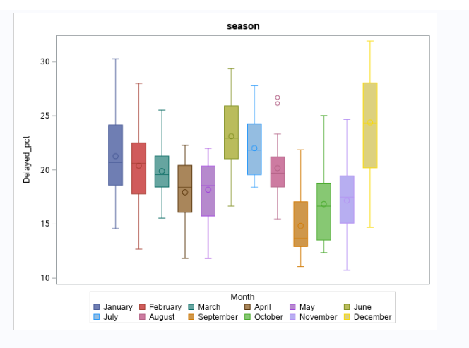

In the first five months, January through May, the median of flight delays does not noticeably deviate from 20 percent. In June, though the maximum flight delays remains the same, the minimum becomes higher, as does the median. The minimum increases to about 17 percent and the median increases to about 23 percent. The next two months, July and August, the median decreases slightly but the flight delay medians and minimums remain higher than the first five months. There is a steep decrease in September, in regards to the lower quartile, upper quartile, the median, minimum, and maximum. As the months continue, there is a general increase in all quartiles and once December is encountered, there is a large spike in the median, the upper quartile, and the maximum. December has the highest median, upper quartile, and maximum of any of the twelve months.

In figure 2, the months were reassigned one of four seasons and the seasonal flight delay percentages are being compared in a box plot.

**Figure 2: Box Plot of Seasons versus Delayed Flight Percentage**

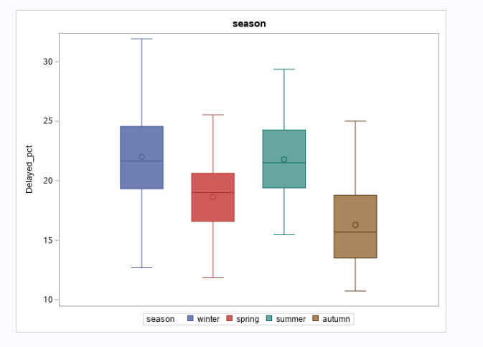

Description of plot

In figure 3, the scatterplot matrix includes all variables in the dataset and their comparison to the flight delay percentage variable. The middle bottom and right bottom graphs will be further examined given that they pertain to seasons and months.

**Figure 3: Scatter Plot Matrix of All Variables versus Delayed Percentage**

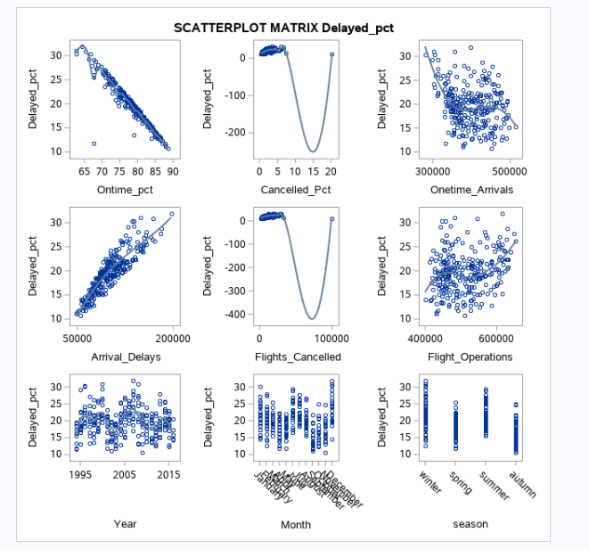

Description of relevant plots (months, seasons)

**Methodology and Discussion**

The purpose of this research is to determine whether or not there is any relation between seasons’ flight delay percentages. The variables tested were months, seasons, and the flight delayed percentages. In order to test if there is indeed a relationship between seasons’ flight delay percentages, first a non-parametric Wilcoxon test will be performed. Then multiple *t-tests* and an ANOVA will be run in order to establish consistency in the dataset and conclusions.

The Wilcoxon test is a non-parametric test alternative to *t-tests*, relying on dependent samples. The Wilcoxon test will first be performed in order to compare seasons and whether their flight delay population mean ranks differ. The assumptions made about the flight delay dataset obtained from the United States Department of Transportation (2016) for the Wilcoxon test include that all observations from both groups are independent of one another and that one can at least say that for any of the two observations, one is larger. Because the Wilcoxon test is a non-parametric test, the flight delay percentages need not be specially distributed.

**Figure 4: Wilcoxon Test Rank Sums**

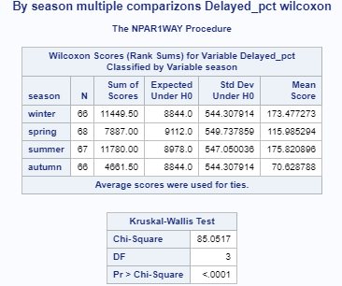

The option DSCF was specified. This procedure calls Dwass, Steel, Critchlow-Fligner (DSCF) multiple comparison analysis test, which is based on pairwise two-sample Wilcoxon comparisons. This test is available if the number of CLASS variable levels is greater then two.

We have 4 number of samples (seasons) and therefore n(n-1)/2=4*3/2=6 pairs of samples.

For each pair of samples npar1way computes the standardized Wilcoxon test statistics.

This test statistic has an asymptotic chi-square distribution with 3 degrees of freedom.

The DSCF statistic for a pair of samples is computed as √2 z, where z is the two-sample standardized Wilcoxon statistic.

Seeing as the primary hypothesis is that there will be a difference between seasons’ delay percentages, for the Wilcoxon test, the null hypothesis is that the distributions of each seasons’ flight delay percentages are the same. The alternative hypothesis is that the distributions of each seasons’ flight delay percentages are different.

**Figure 5: Wilcoxon Test Significance**

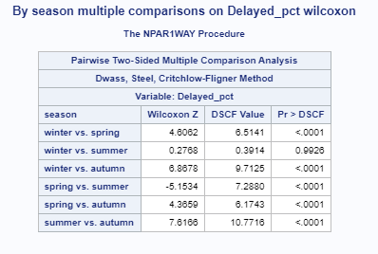

Per figure 5, The exact *p-value* is less than 0.0001 for the flight delay percentages of spring and summer, spring and autumn, spring and winter, summer and autumn, and autumn and winter. The exact *p-value* for summer and winter, however, is 0.9926. At an *alpha-value* of 0.05, the decision is to reject the null hypothesis for the following pairs of seasons: spring and summer, spring and autumn, spring and winter, summer and autumn, and autumn and winter. And so, one can conclude that there is evidence that the distribution of flight delay percentages for the seasonal pairs spring and summer, spring and autumn, spring and winter, summer and autumn, and autumn and winter are different. However, for the pair summer and winter, given that the *p*-*value* is greater than an *alpha-value* of 0.05, the null hypothesis cannot be rejected. There is insufficient evidence that the distribution of flight delay percentages for the seasonal pair summer and winter are different. There is evidence that the distribution of flight delay percentages for some seasonal pairs are different.

The second test performed on the data set was an analysis of variance in order to determine if the Wilcoxon’s results will be supported. Whether or not the mean flight delays are the same for all four seasons will be tested. For the Analysis of Variance test, it is assumed that there is a homogeneity of variances and an independence of cases. The null hypothesis is that the mean flight delay percentage for spring equals the mean flight delay percentage for summer equals the mean flight delay percentage for autumn equals the mean flight delay percentage for winter. The alternative hypothesis is that at least one of the mean flight delay percentages are different. In order to justify that an Analysis of Variance test can be used,

**Figure 6: Analysis of Variance**

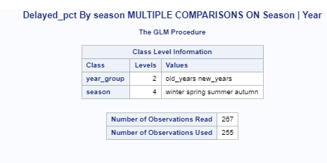

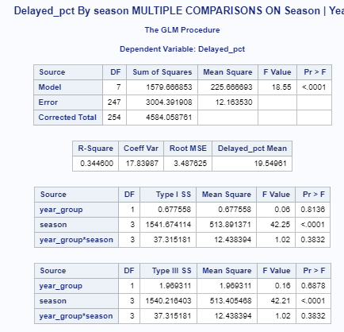

We used the factorial design for class year_group and season group.

Year group contains two levels old years less the 2005 and new years more than 2005.

The year_group*season interactions are not significant therefore we will look at the main effects.

The main effects are year_group and seasons group. The effect of year_group is not significant

But the effect of the season group are significant at alpha=0.05

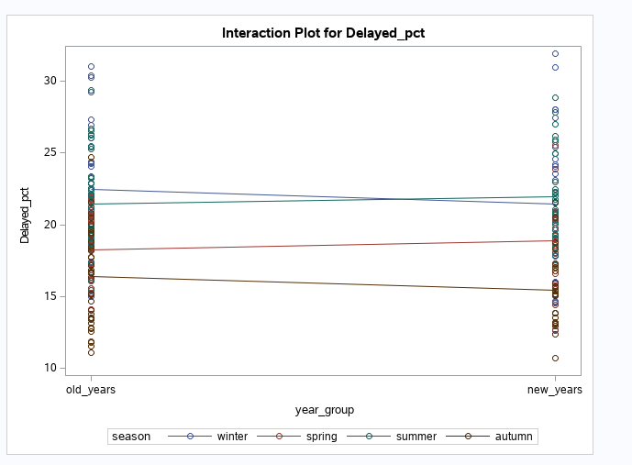

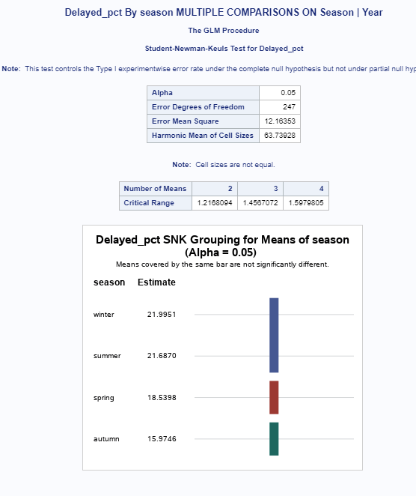

Snk test for the season shows that Dilayed_pct for summer and winter have approximately the same means but they are not the same for other two seasons spring and autumn.

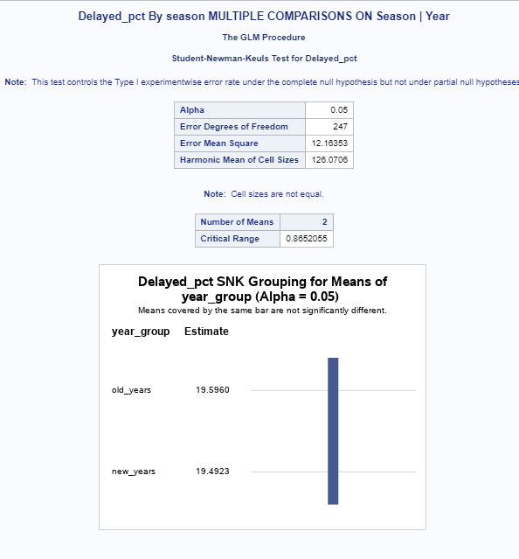

Results of snk for year group shows that there is no difference for Delayed_pct in older years compare to the newer years.At the end of the Glm test provided the means request.

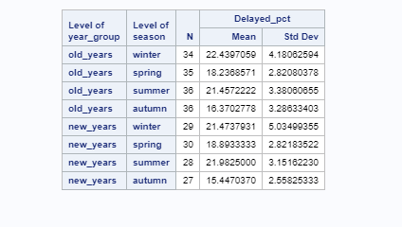

Means Plot.

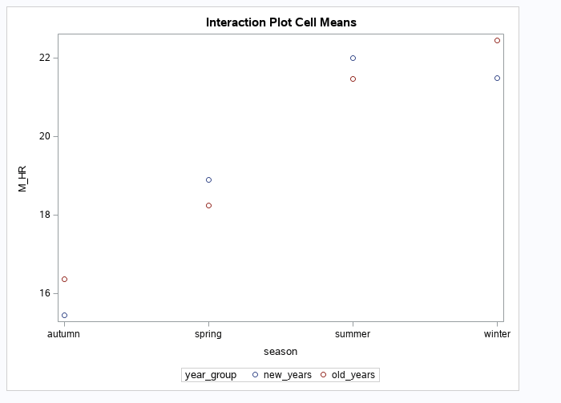

The test statistic, per figure 6, is *F*=18.55 and the *p-value* is less than 0.0001. The decision is to reject the null hypothesis. There is convincing evidence that at least one of the mean total flight delays differ across seasons and so, the results of the Analysis of Variance test concur with the Wilcoxon test, *t-tests* will be utilized in order to determine which seasons have significantly higher flight delay percentages than others.

The next test performed on the dataset obtained from the United States Department of Transportation (2016) was a *t-tes*t analysis in order to determine whether or not each of the seasons had a significant difference in delayed flight percentages. The hypothesis is that for each season, there will be a significant difference in delayed flight percentages. The first *t-test* performed was concerning winter and spring. In order to determine if the pooled or Satterthwaite method ought to be utilized for the test, the equality of variances must be analyzed. The null hypothesis of the equality of variances is that the variance for the delayed percentages for flights in winter and spring are equal to one another. The alternative hypothesis is that the variances for the delayed percentages of flights in winter and spring are not equal to one another. The test statistic for the equality of variances, *f-statistic*, was found to be 2.58, per figure 7, with a *p-value* of 0.0002 which is less than an *alpha-value* of 0.05. And so, the null hypothesis can be rejected. There is a difference in variances between the delayed flight percentages for winter and spring. The conclusion is that the Satterthwaite method will be used for unequal variances.

**Figure 7: *T-Test* for Winter versus Spring**

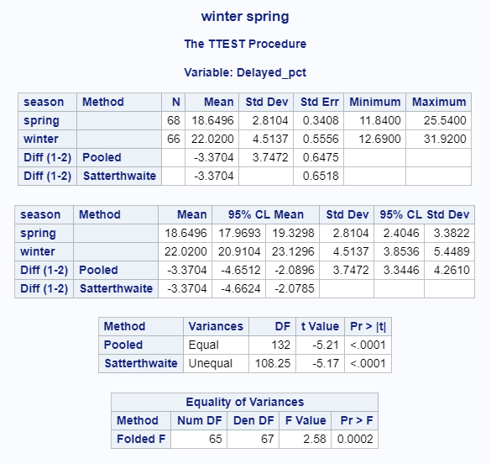

In regards to the *t-test* itself, the null hypothesis is that the means of the delayed percentage of flights for winter and spring are equal to one another. The alternative hypothesis is that the means of the delayed percentages for winter and spring are not equal. The *t-statistic* was found to be -5.17, per figure 7, with a *p-value* of less than 0.0001. Seeing as the *p-value* is less than an *alpha-value* of 0.05, the null hypothesis can be rejected. One can affirm that the means of the delayed percentages for winter and spring are not equal. And so, the flight delay percentages in the winter are, with 95 percent confidence, between 4.6624 percentage points and 2.0785 percentage points, higher than the flight delay percentages in the spring.

The subsequent *t-tests* performed with the United States Department of Transportation (2016) are all done in order to determine whether or not there are significant differences in delayed flight percentages by season. The second *t-test* performed was concerning winter and summer. In order to determine if the pooled or Satterthwaite method ought to be utilized for the test, the equality of variances must be analyzed. The null hypothesis of the equality of variances is that the variance for the delayed percentages for flights in winter and summer are equal to one another. The alternative hypothesis is that the variances for the delayed percentages of flights in winter and summer are not equal to one another. The test statistic for the equality of variances, *f-statistic*, was found to be 1.95, per figure 8, with a *p-value* of 0.0078 which is less than an *alpha-value* of 0.05. And so, the null hypothesis can be rejected. There is a difference in variances between the delayed flight percentages for winter and summer. The conclusion is that the Satterthwaite method will be used for unequal variances.

**Figure 8: *T-Test* for Winter versus Summer**

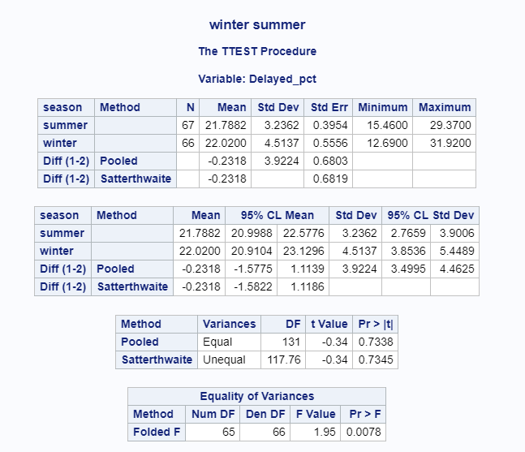

In regards to the *t-test* itself, the null hypothesis is that the means of the delayed percentage of flights for winter and summer are equal to one another. The alternative hypothesis is that the means of the delayed percentages for winter and summer are not equal. The *t-statistic* was found to be -0.34, per figure 8, with a *p-value* of 0.7345. Seeing as the *p-value* is not less than an *alpha-value* of 0.05, the null hypothesis cannot be rejected. One can affirm only that there is insufficient evidence to reject the null hypothesis that the means of the delayed percentages for winter and summer are equal.

The third *t-test* performed was concerning winter and autumn. In order to determine if the pooled or Satterthwaite method ought to be utilized for the test, the equality of variances must be analyzed. The null hypothesis of the equality of variances is that the variance for the delayed percentages for flights in winter and autumn are equal to one another. The alternative hypothesis is that the variances for the delayed percentages of flights in winter and autumn are not equal to one another. The test statistic for the equality of variances, *f-statistic*, was found to be 1.88, per figure 9, with a *p-value* of 0.0118 which is less than an *alpha-value* of 0.05. And so, the null hypothesis can be rejected. There is a difference in variances between the delayed flight percentages for winter and autumn. The conclusion is that the Satterthwaite method will be used for unequal variances.

**Figure 9: *T-Test* for Winter versus Autumn**

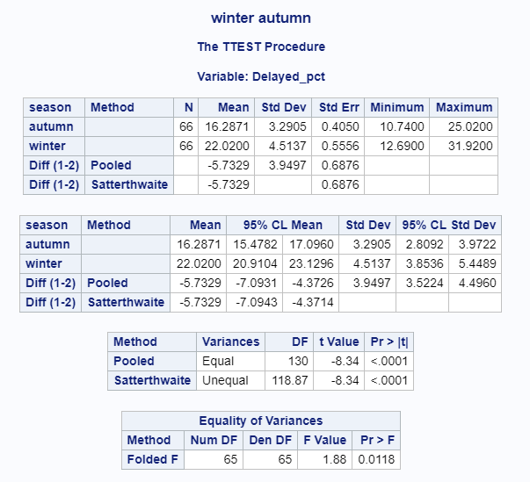

In regards to the *t-test* itself, the null hypothesis is that the means of the delayed percentage of flights for winter and autumn are equal to one another. The alternative hypothesis is that the means of the delayed percentages for winter and autumn are not equal. The *t-statistic* was found to be -8.34, per figure 9, with a *p-value* of less than 0.0001. Seeing as the *p-value* is less than an *alpha-value* of 0.05, the null hypothesis can be rejected. One can affirm that the means of the delayed percentages for winter and autumn are not equal. And so, the flight delay percentages in the winter are, with 95 percent confidence, between 4.3714 percentage points and 7.0943 percentage points, higher than the flight delay percentages in the autumn.

The fourth *t-test* performed was concerning spring and summer. In order to determine if the pooled or Satterthwaite method ought to be utilized for the test, the equality of variances must be analyzed. The null hypothesis of the equality of variances is that the variance for the delayed percentages for flights in spring and summer are equal to one another. The alternative hypothesis is that the variances for the delayed percentages of flights in spring and summer are not equal to one another. The test statistic for the equality of variances, *f-statistic*, was found to be 1.33, per figure 10, with a *p-value* of 0.2522 which is more than an *alpha-value* of 0.05. And so, the null hypothesis cannot be rejected. There is no difference in variances between the delayed flight percentages for winter and autumn. The conclusion is that the pooled variances method will be used for equal variances.

**Figure 10: *T-Test* for Spring versus Summer**

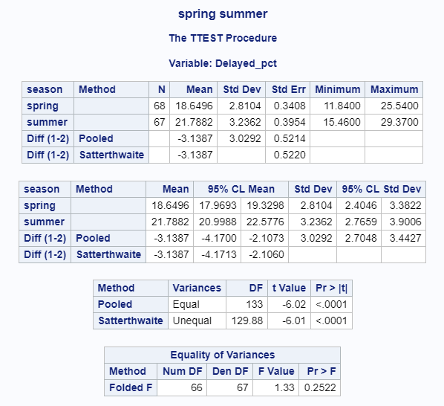

In regards to the *t-test* itself, the null hypothesis is that the means of the delayed percentage of flights for winter and autumn are equal to one another. The alternative hypothesis is that the means of the delayed percentages for spring and summer are not equal. The *t-statistic* was found to be 6.02, per figure 10, with a *p-value* of less than 0.0001. Seeing as the *p-value* is less than an *alpha-value* of 0.05, the null hypothesis can be rejected. One can affirm that the means of the delayed percentages for spring and summer are not equal. And so, the flight delay percentages in the summer are, with 95 percent confidence, between 2.1073 percentage points and 4.17 percentage points, higher than the flight delay percentages in the spring.

The fifth *t-test* performed was concerning spring and autumn. In order to determine if the pooled or Satterthwaite method ought to be utilized for the test, the equality of variances must be analyzed. The null hypothesis of the equality of variances is that the variance for the delayed percentages for flights in spring and autumn are equal to one another. The alternative hypothesis is that the variances for the delayed percentages of flights in spring and autumn are not equal to one another. The test statistic for the equality of variances, *f-statistic*, was found to be 1.37, per figure 11, with a *p-value* of 0.2020 which is more than an *alpha-value* of 0.05. And so, the null hypothesis cannot be rejected. There is no difference in variances between the delayed flight percentages for spring and autumn. The conclusion is that the pooled variances method will be used for equal variances.

**Figure 11: *T-Test* for Spring versus Autumn**

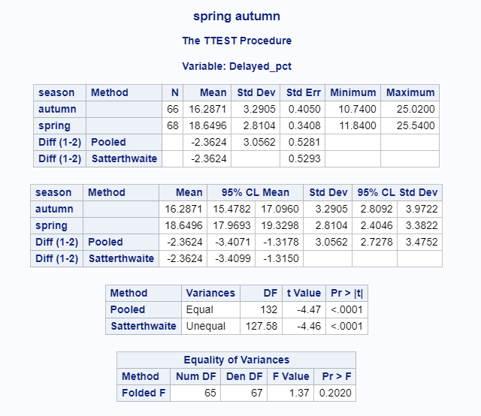

In regards to the *t-test* itself, the null hypothesis is that the means of the delayed percentage of flights for spring and autumn are equal to one another. The alternative hypothesis is that the means of the delayed percentages for spring and autumn are not equal. The *t-statistic* was found to be -4.47, per figure 11, with a *p-value* of less than 0.0001. Seeing as the *p-value* is less than an *alpha-value* of 0.05, the null hypothesis can be rejected. One can affirm that the means of the delayed percentages for spring and autumn are not equal. And so, the flight delay percentages in the spring are, with 95 percent confidence, between 1.3178 percentage points and 3.4071 percentage points, higher than the flight delay percentages in the autumn.

The sixth *t-test* performed was concerning summer and autumn. In order to determine if the pooled or Satterthwaite method ought to be utilized for the test, the equality of variances must be analyzed. The null hypothesis of the equality of variances is that the variance for the delayed percentages for flights in summer and autumn are equal to one another. The alternative hypothesis is that the variances for the delayed percentages of flights in summer and autumn are not equal to one another. The test statistic for the equality of variances, *f-statistic*, was found to be 1.03, per figure 12, with a *p-value* of 0.8928 which is more than an *alpha-value* of 0.05. And so, the null hypothesis cannot be rejected. There is no difference in variances between the delayed flight percentages for spring and autumn. The conclusion is that the pooled variances method will be used for equal variances.

**Figure 12: *T-Test* for Summer versus Autumn**

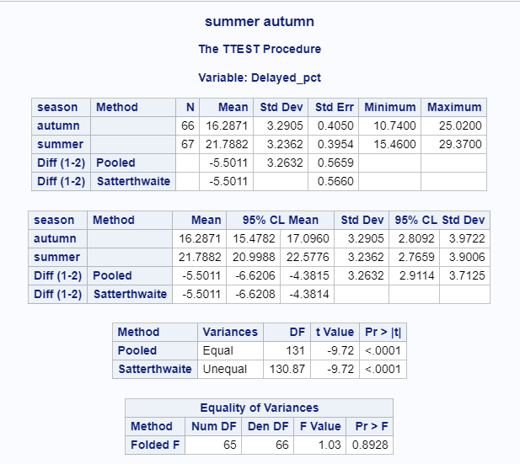

In regards to the *t-test* itself, the null hypothesis is that the means of the delayed percentage of flights for summer and autumn are equal to one another. The alternative hypothesis is that the means of the delayed percentages for summer and autumn are not equal. The *t-statistic* was found to be -9.72, per figure 12, with a *p-value* of less than 0.0001. Seeing as the *p-value* is less than an *alpha-value* of 0.05, the null hypothesis can be rejected. One can affirm that the means of the delayed percentages for summer and autumn are not equal. And so, the flight delay percentages in the summer are, with 95 percent confidence, between 4.3815 percentage points and 6.6206 percentage points, higher than the flight delay percentages in the autumn.

**V. SUMMARY AND CONCLUSION/RECOMMENDATION**

Per the Wilcoxon and Analysis of Variance tests, there is convincing evidence that at least one of the mean total flight delays differ across seasons, the distribution of flight delay percentages for some seasonal pairs are different. In regards to the *t-tests*, flight delay percentages in the winter are, with 95 percent confidence between 4.3714 percentage points and 7.0943 percentage points, higher than the flight delay percentages in the autumn. Flight delay percentages in the winter are, with 95 percent confidence, between 4.6624 percentage points and 2.0785 percentage points, higher than the flight delay percentages in the spring.

In regards to winter and summer, one can affirm only that there is insufficient evidence to reject the null hypothesis that the means of the delayed percentages for winter and summer are equal. The flight delay percentages in the summer are, with 95 percent confidence, between 2.1073 percentage points and 4.17 percentage points, higher than the flight delay percentages in the spring. The flight delay percentages in the summer are, with 95 percent confidence, between 4.3815 percentage points and 6.6206 percentage points, higher than the flight delay percentages in the autumn.Finally, the flight delay percentages in the spring are, with 95 percent confidence, between 1.3178 percentage points and 3.4071 percentage points, higher than the flight delay percentages in the autumn.

Given the outcomes and conclusions, the decision based on the research is that the flight delays for the winter and summer season are greater than the flight delays in the spring season, and these three seasons all have greater flight delays than in the autumn season. This decision supports the initial hypothesis, that there will be a difference between seasons’ delay percentages. However, in regards to winter and summer, there is insufficient evidence to say that there is a difference between summer and winter seasonal flight delays. Given this decision, it is recommended one travel in the autumn for vacation in order to better avoid flight delays given this season had the least delays compared to *all* other seasons.

With only two variables, amount of tests run were limited, with most of the conclusions being drawn from *t-tests*. The inclusion of the cancellation of flights could have been included in the study, drawing conclusions about both cancellations and delays. However, with the inclusion of the cancellation of flights, one runs the risk of comparing cancellations to delays which is not recommended given that cancellations and delays are not independent of one another. In regards to the use of variables in future studies, it is encouraged to use the seasonal variable in future studies seeing as this variable reduces the objects in said variable (from twelve objects in the “months” variable to four objects) but still preserves the trends observed in the “months” variable per figures 1 and 2.

In regards to future research, it is recommended to test the relationship between seasons and flight cancellations. It is also recommended that the correlation between flight delays, flight cancellations, and flight arrivals in each season be analyzed. However, when analyzing multiple numerical variables such as flight delays and cancellations, one runs the risk of analyzing variables that are dependent on one another and may incur confounding variables. And so, it is advised to focus primarily on seasons and their flight patterns, be it an arrival, cancellation, or delay pattern.

**VI. REFERENCES**

Baumeister, R. F., Bratslavsky, E., Finkenauer, C., & Vohs, K. (2001). Bad is Stronger than Good. *Review of General Psychology,* *5*. doi:10.1037/e413792005-154

Blackwood, Paul. (2012).Understanding Flight Delays at U.S. Airports in 2010, Using Chicago O'Hare International Airport as a Case Study. Master's Theses. 45.<https://scholarworks.wmich.edu/masters_theses/45>

Dyer, K. (2016, December 15). Why is on time performance important to airlines. Retrieved March 5, 2019, from <https://www.flightstats.com/company/why-is-on-time-performance-important-to-airlines/>

Sridhar, B., Wang, Y., Klein, A., & Jehlen, R. (2009). Modeling Flight Delays and Cancellations at the National, Regional and Airport Levels in the United States. Retrieved March 10, 2019, from https://pdfs.semanticscholar.org/43cf/8b7266bed9737a50c850e88767051bee60da.pdf.

U. S. Department of Transportation (2016). Flights on time 2016. Retrieved March 1, 2019, from <https://dasl.datadescription.com/datafile/flights-on-time-2016/>

U. S. Department of Transportation (2018).Flight Delays & Cancellations. Retrieved March 7, 2019, from <https://www.transportation.gov/individuals/aviation-consumer-protection/flight-delays-cancellations>

Zou, B., & Hansen, M. (2010). Flight delay impact on airfare and flight frequency: A comprehensive assessment. *Transportation Research Part E: Logistics and Transportation Review,* *69*, 1-94. doi:10.1016/j.tre.2014.05.016

**VII. APPENDIX**

proc import datafile='/folders/myfolders/data/project/flights.txt'

out=flights

dbms=dlm

replace;

datarow=5;

delimiter='09'x;

run;

data new;

set flights;

year_dec=scan(year,2,'.');

year=scan(year,1,'.');

if Month='January' then month_count=1;

else if Month='February' then month_count=2;

else if Month='March' then month_count=3;

else if Month='April' then month_count=4;

else if Month='May' then month_count=5;

else if Month='June' then month_count=6;

else if Month='July' then month_count=7;

else if Month='August' then month_count=8;

else if Month='September' then month_count=9;

else if Month='October' then month_count=10;

else if Month='November' then month_count=11;

else if Month='December' then month_count=12;

if Month='December' or Month='January' Or Month='February' then season='winter' ;

else if Month='March' or Month='April' or Month='May' then season='spring';

else if Month='June' or Month='July' or Month='August' then season='summer';

else if Month='September' or Month='October' or Month='November' then season='autumn';

if season='winter' then season_count=1;

else if season='spring' then season_count=2;

else if season='summer' then season_count=3;

else if season='autumn' then season_count=4;

if Year <= 2005 then year_group='old_years';

else if Year > 2005 then year_group='new_years';

run;

proc sort data=new;

By month_count;

run;

proc sort data=new;

By season_count;

run;

PROC SORT DATA = new;

BY month_count ;

Run;;

proc sort data=new;

by season_count;

proc sgscatter data=new;

title 'Descriptive Statistics By Season';

matrix Delayed_pct Ontime_pct Cancelled_Pct Flight_Operations / group=season diagonal=(histogram kernel);

run;

proc ttest data=new;

where season in('winter','spring');

title 'winter spring';

class season;

var Delayed_pct;

Run;

proc ttest data=new;

where season in('winter','summer');

title 'winter summer';

class season;

var Delayed_pct;

Run;

proc ttest data=new;

where season in('winter','autumn');

title 'winter autumn';

class season;

var Delayed_pct;

run;

proc ttest data=new;

where season in('spring','summer');

title 'spring summer';

class season;

var Delayed_pct;

Run;

proc ttest data=new;

where season in('spring','autumn');

title 'spring autumn';

class season;

var Delayed_pct;

run;

proc ttest data=new;

where season in('summer','autumn');

title 'summer autumn';

class season;

var Delayed_pct;

Run;

proc npar1way data=new wilcoxon dscf;

title 'By season multiple comparisons on Delayed_pct';

class season;

var Delayed_pct;

run;

proc reg data=new;

model Delayed_pct Arrival_Delays = Ontime_pct Onetime_Arrivals month_count Flight_Operations/clb;

run;

proc glm data=new ORDER = DATA ;

title 'Arrival_Delays By season Month MULTIPLE COMPARISONS ON Month | Year';

class year_group Month;

model Arrival_Delays=year_group | Month;

means year_group | Month / snk;

Run;